Candidate’s Name

|  |  |  |  |  |  |  |  |
| --- | --- | --- | --- | --- | --- | --- | --- |
| …………………………………………………………… | Centre No | | | | Personal No | | |
| Signature:………………………….. |  |  |  |  |  |  |  |

**UGANDA CERTIFICATE OF EDUCATION**

**MOCK EXAMINATIONS 2016**

**535/1 PHYSICS**

**PAPER 1**

TIME: 2 HOURS 15 MINUTES

***Instructions to candidates***

* *Write your name, centre/Index number and signature in the space above*
* *Section* ***A*** *contains 40 objective type questions. You are required to write the correct answer* ***A,B,C*** *or* ***D*** *in the boxes at the right hand side*
* *Section* ***B*** *contains* ***10*** *structured questions. Answers are to be written in the spaces provided on the question paper.*
  + *Acceleration due to gravity = 10ms – 2*
  + *Specific heat capacity of water = 4200Jkg – 1 K – 1*

**For Examiners use only**

|  |  |  |  |  |  |  |  |  |  |  |  |
| --- | --- | --- | --- | --- | --- | --- | --- | --- | --- | --- | --- |
| **Qn 41** | **Qn 42** | **Qn 43** | **Qn 44** | **Qn45** | **Qn46** | **Qn47** | **Qn48** | **Qn49** | **Qn50** | **MCQ** | **Total** |
|  |  |  |  |  |  |  |  |  |  |  |  |
|  |  |  |  |  |  |  |  |  |  |  |  |

**SECTION A (40 MARKS)**

*Answer* ***all*** *questions in this section*

1. A Pendulum bob moves 50 complete oscillations in 2 minutes, calculate the period of the swing in seconds.

A 0.02 B .2.4 C. 2.5 D. 0.42

1. The following types of waves travel at the speed of light except

A. radio waves

B. radar waves

C. water waves

D. infrared waves

1. In a simple cell electrons flow from

A. the copper plate

B. the zinc plate

C. dilute sulphuric acid

D. potassium dichromate

1. Stone 8N

6N

**Fig 1**

Fig 1 shows the forces acting on a stone of mass 2.5kg. calculate the acceleration produced on the stone.

1. 40 ms-2 C. 5.6 ms-2
2. 2.5 ms-2 D. 4.0ms-2
3. When a body is thrown vertically upwards
4. its initial velocity is greater than zero
5. its velocity at maximum height is zero
6. its acceleration upwards is positive
7. it moves with uniform velocity
8. (i) and (ii) B. (i) and (iii) C. (ii) and (iii) D. (iii) and (iv)
9. Which of the following statements is correct about soft ferromagnetic materials
10. they don’t lose their magnetism easily
11. they are easily and strongly magnetized
12. they are used to make permanent magnets

A. (i) and (ii) only B. (ii) and (iii) only

C. (ii) only D. (iii) only

1. When a substance is boiling, its saturated vapour pressure is

A. maximum C. above the atmospheric pressure

B. minimum D. equal to the atmospheric pressure

1. When an uncharged conductor is brought near the cap of a positively charged electroscope, the gold leaf

A. gains a positive charge

B. increases the divergence

C. decreases in divergence

D. remains uncharged

1. 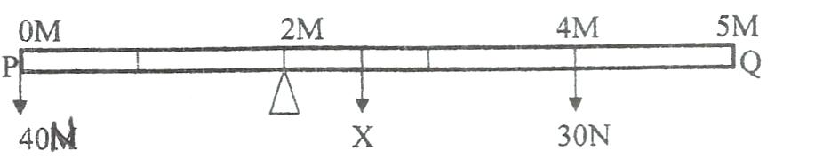

**Fig 2**

Fig 2 shows a uniform pole **PQ** of length 5m pivoted 2m from end **P**. A force of 40N suspended at **P**. and 30N suspended one metre from end **Q** make it balance horizontally. Find the weight **x** of the pole.

1. 90N B. 40N C. 60N D. 70N
2. Two resistors of 7Ω and 3Ω are connected as shown in fig 3.

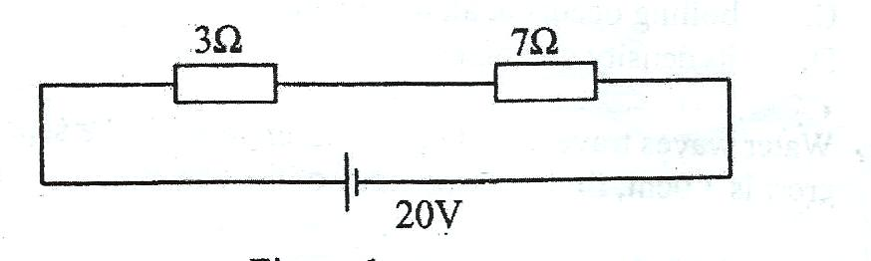

**Fig.3**

The current through the 7Ω resistor is

1. 0.5A
2. 2.0A
3. 2.8A
4. 9.5A
5. When the amplitude of vibration of the cone of a loud speaker increases, the sound produced becomes

A. High pitched

B. Low pitched

C. Louder

D. Softer

1. Which one of the following colours is used for the live wire in three core cables?

A. Brown B. Black C. Yellow D. Blue

1. The diagrams show different arrangements of two strong magnets. Which pair of magnets will pull each other

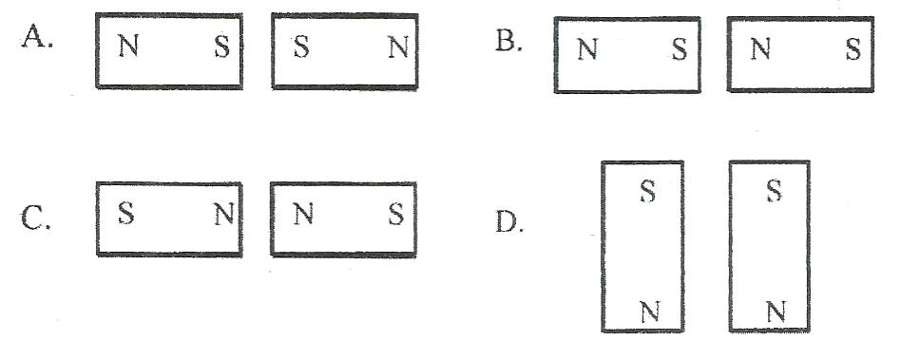

1. Which of the following is not a vector quantity

A. Magnetic flux

B. Momentum

C. Pressure

D. Weight

1. An image 5cm high is formed by a converging lens. If the magnification is 0.4, find the height of the object

A. 2.0 cm B. 4.6 cm C. 5.4 cm D. 12.5 cm

1. Calculate the amount of heat required to raise the temperature of 0.2kg of lead by 600c

(Specific heat capacity of lead =130 Jkg-1 K -1)

1. 156J B. 1140J C. 1560J D. 340J
2. Which of the following are properties of cathode rays
3. they are electrically neutral
4. they travel in a straight line
5. they are deflected by magnetic fields
6. (i) and (ii) only
7. (i)and (iii) only
8. (ii) and (iii) only
9. (i), (ii) and (iii)
10. Fig 4 shows two waves representing two musical notes

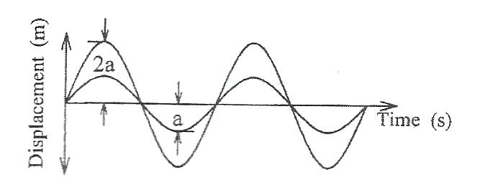

**Fig 4**

Which of the following statements is true?

1. The two waves produce sound of different pitch
2. The two waves produce sound of different wave length
3. The two waves produce sound of the same loudness
4. The two waves produce sound of different loudness
5. A converging mirror produces a virtual, magnified and erect image when

A. The object is between the pole and the principal focus

B. The object is between the principal focus and the centre of curvature

C. The object is beyond the centre of curvature

D. The object is at infinity

1. The inner walls of a vacuum flask are highly polished to,

A. Reduce heat loss by convection

B. Prevent heat loss by radiation

C. Reduce heat loss by evaporation

D. Reduce heat loss by conduction

1. Fig 5 shows levels of water in a measuring cylinder before and after immersing a solid **X** of mass 40g.

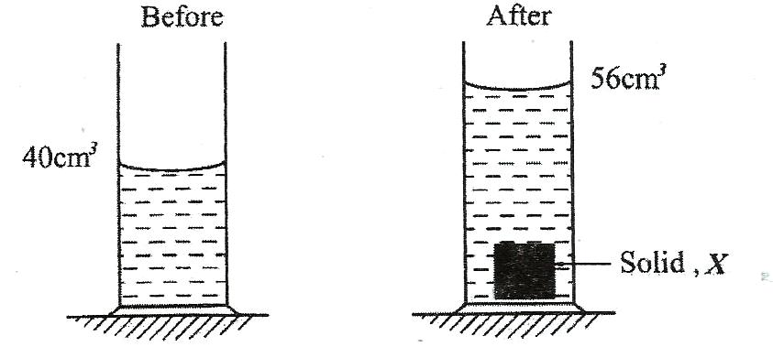

**Fig 5**

The density of solid X in gcm-3 is

1. 1.0 B. 1.4 C. 2.4 D. 2.5
2. The volume of a gas is 150cm3 at 270c and 770mmHg pressure. Calculate the volume of the gas at s.t.p (00c and 760mmHg)

A. $\frac{760 × 770×300}{150×273}$ B . $\frac{770×760×273}{150×300}$

C. $\frac{150×770×273}{760×300}$ C . $\frac{760×770×150}{300×273}$

1. Electromagnets are used in all the following appliances except

A. telephone

B. loud speaker

C. electric bell

D. thermostat

1. Which one of the following graphs represents the variation of extension of a spring with load.

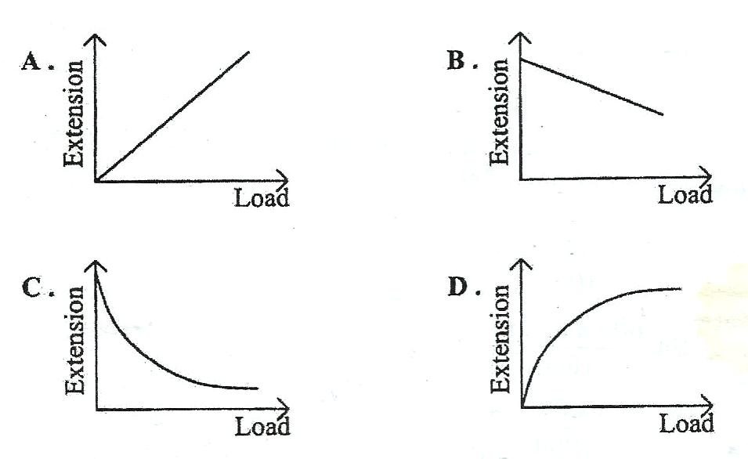

1. A d.c motor converts

A. electrical energy to mechanical energy

B. mechanical energy to electrical energy

C. Kinetic energy to potential energy

D. potential energy to kinetic. Energy

1. Find the cost of running six 100W lamps and three 75W lamps for 8 hours if the cost of one unit of electric power is shs 214
2. Shs $\frac{825×8×214}{1000}$
3. Shs $\frac{600×8×214}{1000}$
4. Shs $\frac{225×8×214}{1000}$
5. Shs $\frac{175×8×9}{1000}$
6. The equation below represents a radioactive decay in which a particle **P** is emitted

+ **P**

If A= 284 and Z=88. Identify particle **P**

1. Beta Particle
2. Alpha Particle
3. Gamma rays
4. Neutron
5. A source produces waves which travel a distance of 140cm in 0.08seconds. If the distance between successive crests is 20m find the frequency of the source.

A. 87.50Hz

B. 0.875Hz

C. 0.0875Hz

D. 8750Hz

1. Isotopes of an element
2. have same physical properties
3. have equal number of protons
4. have different number of neutrons

A. (i) only

B. (i) and (ii) only

C. (ii) and (iii) only

D. (i) and (iii) only

1. A body accelerates uniformly from rest and acquires a velocity of 60ms-1 after half a minute. Find the distance covered by the body.

A. 15m B.30m C.1800m D.900m

1. Which one of the following parts of the eye acts like the film in a lens camera

A. pupil B. iris C. cornea D. retina

1. Which of the following takes place as water waves travel from shallow end to the deep end of a ripple tank?

|  |  |  |  |
| --- | --- | --- | --- |
|  | **Speed** | **Frequency** | **Wavelength** |
| **A** | Increases | Remains the same | Remains the same |
| **B** | Decreases | Remains the same | Decreases |
| **C** | Increases | Remains the same | Increases |
| **D** | Increases | Increases | Increase |

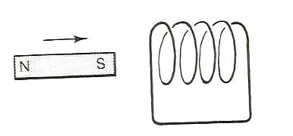



Solenoid

Galvanometer

**Fig 6**

Figure 6 shows an arrangement where is plugged into a solenoid then withdrawn. Which of the following is the correct observation?

1. The galvanometer doesn’t deflect
2. The galvanometer deflects in one direction
3. The galvanometer deflects in one direction then in the opposite direction
4. The galvanometer continuously oscillates in either direction
5. The lead-acid cell is called a secondary cell because

A. Its output voltage is 2volts

B. It can be recharged

C. It has two lead electrodes

D. It can’t be recharged

1. A Material which undergoes a large amount of extension before it breaks is called

A. ductile

B. brittle

C. plastic

D. elastic

1. The amount of heat absorbed by a body of mass 2kg at a constant temperature is called

A. latent heat

B. heat capacity

C. specific heat capacity

D. specific latent heat

1. Four cells each of emf 1.5V and internal resistance 1.0 Ω are connected in series with a resistor of 8.0 Ω. Calculate the value of the current that flows.

A. 2.0 A

B. 1.5 A

C. 1.0 A

D. 0.5 A

1. What is the appearance of a blue curtain with red flowers in green light?

|  |  |  |
| --- | --- | --- |
|  | **Appearance of curtain** | **Appearance of flower** |
| **A** | Blue | Red |
| **B** | Black | Green |
| **C** | Black | Black |
| **D** | Red | Black |

1. The advantage of mercury over alcohol as a thermometric liquid are;
2. mercury is opaque
3. mercury doesn’t wet glass
4. mercury is a good conductor of heat

A. (i) and (iii) only

B. (i),(ii) and (iii)

C. (i) and (ii) only

D. (i) only

1. The power of a lens is 25 Dioptre find the focal length of this lens in cm.

A. 0.25 B. 0.04 C. 2.5 D. 4.0

**SECTION B**

*Answer* ***all*** *the questions in this section*

1. (a) Define the term potential difference and state its **SI** unit. (01mark)

………………………………………………………………………………………………………………………………………………………………………………

………………………………………………………………………………………

(b)

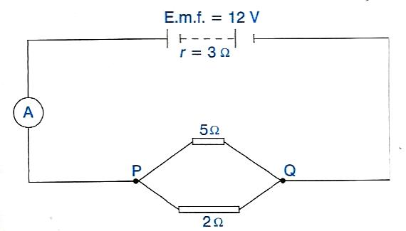

**Fig.7**

Figure 7 shows a battery of e.m.f 12V and total internal resistance of 3Ω. It is placed in series with two resistors and an ammeter of 1Ω resistance .Determine the reading of the ammeter. (03marks)

………………………………………………………………………………………………………………………………………………………………………………

………………………………………………………………………………………………………………………………………………………………………………

………………………………………………………………………………………………………………………………………………………………………………

1. (a) State **one** factor which affects the speed of sound in air. (01mark)

………………………………………………………………………………………………………………………………………………………………………………

(b) A loud speaker placed between two walls but nearer to wall A than wall **B** is sending out constant sound waves. Determine how far the loud speaker is from wall **B** if it’s 100m from wall A and the time between the two echoes received is 0.2 seconds .(Speed of sound in air = 340ms-1) (03marks)

………………………………………………………………………………………………………………………………………………………………………………

………………………………………………………………………………………………………………………………………………………………………………

………………………………………………………………………………………………………………………………………………………………………………

1. (a) Define the term cathode rays. (01marks)

………………………………………………………………………………………………………………………………………………………………………………

(b) The wave form shown in figure 8 was produced on C.R.O when a certain oscillating source was connected to the Y-plated of the C.R.O

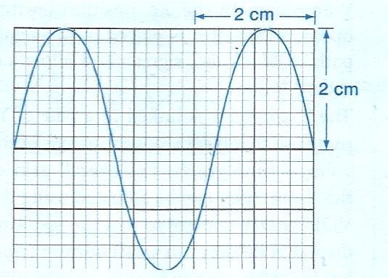

**Fig.8**

The Y-gain reads 0.5Vcm-1 while the time based reads 10mscm-1.

Determine:

1. the peak voltage of the wave form. (01mark)

………………………………………………………………………………………………………………………………………………………………………………

1. The frequency of the wave. (02marks)

………………………………………………………………………………………………………………………………………………………………………………………………………………………………………………………………………………………………………………………………………………………………………………………………………………………………………………………

1. (a) State Hooke’s law. (01mark)

………………………………………………………………………………………………………………………………………………………………………………

………………………………………………………………………………………

(b) An unstretched spring has a length of 5.0 cm. A force of 1.0 N caused its length to increase to 7.8 cm. Find the length of the spring when its subjected to the force of 4.0N. (03marks)

………………………………………………………………………………………………………………………………………………………………………………

………………………………………………………………………………………………………………………………………………………………………………

………………………………………………………………………………………………………………………………………………………………………………

1. (a) State Faraday’s law of electromagnetic induction. (01mark)

………………………………………………………………………………………………………………………………………………………………………………

………………………………………………………………………………………………………………………………………………………………………………

(b) A 12V, 48W lamp operates normally when it is connected to a transformer with 300 turns in the secondary and 150 turns in the primary circuit. Calculate the primary voltage. (03marks)

………………………………………………………………………………………………………………………………………………………………………………

………………………………………………………………………………………………………………………………………………………………………………

………………………………………………………………………………………………………………………………………………………………………………

1. (a) Define the term focal length of a lens. (01mark)

………………………………………………………………………………………………………………………………………………………………………………

………………………………………………………………………………………

(b) The critical angle of a certain glass material is 42.70.Determine the refractive index of the material. (03marks)

………………………………………………………………………………………………………………………………………………………………………………

………………………………………………………………………………………………………………………………………………………………………………

1. (a) Define the term half life. (01mark)

………………………………………………………………………………………………………………………………………………………………………………

………………………………………………………………………………………………………………………………………………………………………………

(b) A radioactive nuclide has a half life period of 4 hours. Calculate the mass that would remain after 24 hours if the original mass is 9.6g. (02marks)

………………………………………………………………………………………………………………………………………………………………………………

………………………………………………………………………………………………………………………………………………………………………………

………………………………………………………………………………………

(c) A radioactive nuclide ${}_{27}^{60}{Co}$ decays by the following equation

${}_{27}^{60}{Co }{}_{28}^{60}{Ni +{}_{-1}^{0}{e +P}}$

Identify the radiation **P**. (01mark)

………………………………………………………………………………………………………………………………………………………………………………

1. (a) Define the term **velocity ratio** of a machine. (01mark)

………………………………………………………………………………………………………………………………………………………………………………

………………………………………………………………………………………

(b) A pulley system having three pulleys in the fixed block and two in the movable block is used to raise a load of 600N.If the system has an efficiency of 80% , what effort is required to raise the load. (03marks)

………………………………………………………………………………………………………………………………………………………………………………………………………………………………………………………………………………………………………………………………………………………………………………………………………………………………………………………………………………………………………………………………………………

1. 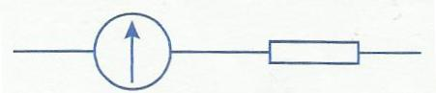 Galvanometer **R**

**Fig 9**

Figure 9 shows a galvanometer adapted for use as voltmeter. If the galvanometer has a resistance of 100 Ω and gives a full scale deflection of 1mA

(a) Name resistor **R** connected to the galvanometer. (1mark)

………………………………………………………………………………………

(b) What is the value of the resistor **R** that must be connected in series with the meter so that it can be used as a voltmeter and read s up to 1V. (03mark)

………………………………………………………………………………………………………………………………………………………………………………

………………………………………………………………………………………………………………………………………………………………………………

………………………………………………………………………………………

1. (a) Define heat capacity. (1mark)

………………………………………………………………………………………

………………………………………………………………………………………………………………………………………………………………………………

(b)

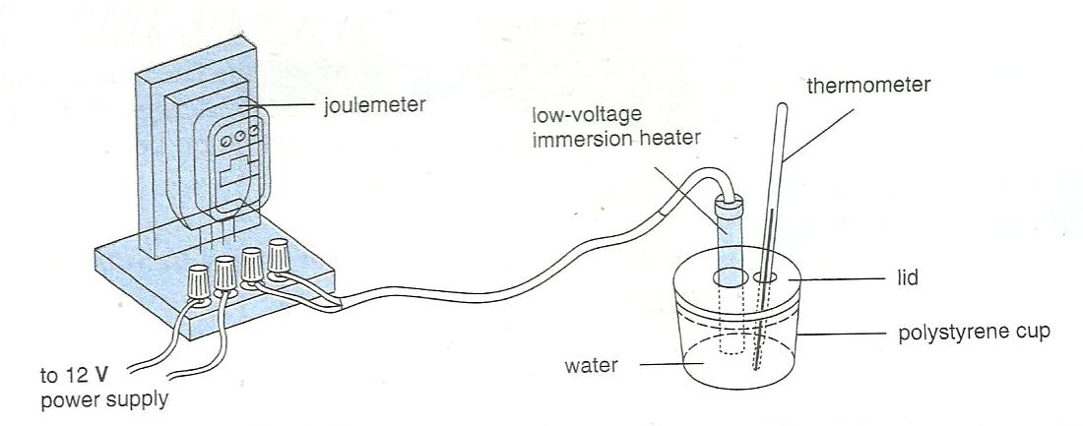

Fig 10

Fig 10 shows an electrical apparatus set up to measure specific heat capacity of a liquid .Given that:

Energy transferred = 12209J

Mass of liquid = 0.8kg

Original temperature = 26.80C

Final temperature = 33.00C

Find the specific heat capacity of the liquid.

………………………………………………………………………………………………………………………………………………………………………………

………………………………………………………………………………………………………………………………………………………………………………

………………………………………………………………………………………………………………………………………………………………………………

**END**